Supplementary Information
Benoît O.L. Demars, Joanna L. Kemp, Baptiste Marteau, Nikolai Friberg, Barry Thornton. 2021. Stream macroinvertebrates and carbon cycling in tangled food webs. Ecosystems.

Method S1
Derivation of macroinvertebrate tissue isotopic ratio turnover rate

Method S2
Code for Monte Carlo simulations in R

Tables and Figures

Figure S1. Biomass and annual secondary production of stream macroinvertebrate communities
Figure S2. Relative changes in macroinvertebrate densities due to sucrose addition
Figure S3. Relative changes in primary carbon sources: autotrophs, bacteria and natural terrestrial organic matter carbon sources in macroinvertebrates due to sucrose addition

Table S1. Carbon isotopic ratio and derived parameters
Table S2. Partitioning the green web and brown web. Proportion of sources in macroinvertebrates before and after sucrose addition in the reference stream
Table S3. Partitioning the green web and brown web. Proportion of sources in macroinvertebrates control and impact of sucrose addition in the treatment stream
Table S4. Tracing the origin of carbon. Proportion of autochthonous and allochthonous sources in macroinvertebrates in the reference and treatment streams following sucrose addition.

Method S1
Derivation of macroinvertebrate tissue isotopic ratio turnover rate λ (day⁻¹) from the isotopic half-life (t_{1/2}, days) relationship with invertebrate biomass M (g).

We have (Vander Zanden and others, 2015):
$$ln\left(t_{1/2}\right)=0.23 ln\left(M\right)+3.25$$
equivalent to,
$$ln\left(t_{1/2}\right)=ln\left(M^{0.23}\right)+3.25$$
$$t_{1/2}=e^{3.25}M^{0.23}$$
$$t_{1/2}=25.8 M^{0.23}$$
Assuming an exponential decrease of tissue isotopic ratio over time, we have (Hobson and Clark, 1992; Vander Zanden and others, 2015):
$$δ_{t}=δ_{n}+\left(δ_{0}-δ_{n}\right)exp⁡(-λt)$$
with δ_{t} isotopic value (‰) of the organism at time t, δ₀ initial isotopic value (‰) at equilibrium with the old diet, δ_{n} isotopic value (‰) after equilibration with the new diet, λ tissue isotopic turnover rate (day⁻¹), and t time since the diet switch (days).
With $δ_{n}=0$, the equation simplifies to:
$$δ_{t}=δ_{0} exp\left(-λt\right)$$
At isotopic ratio half-life we have:$$\frac{δ_{0}}{2}=δ_{0} exp\left(-λt_{1/2}\right)$$
$$ln\left(\frac{δ_{0}}{2}\right)=ln\left(δ_{0}\right)-λt_{1/2}$$
$$t_{1/2}=\frac{ln\left(\frac{δ_{0}}{2}\right)-ln\left(δ_{0}\right)}{-λ}$$
$$t_{1/2}=\frac{ln\left(1/2\right)}{-λ}$$
$$t_{1/2}=\frac{ln\left(2\right)}{λ}$$
And so we have:
$$\frac{ln\left(2\right)}{λ}=25.8 M^{0.23}$$
$$λ=\frac{ln⁡(2)}{25.8 M^{0.23}}$$

Method S2
Code for Monte Carlo simulations in RStudio using R version 3.5.0

Relative changes (effect size) of autotrophs and natural terrestrial organic matter in the diet of macroinvertebrates with data from the BACI (before and after control impact) design; example with proportion of terrestrial organic matter in Leuctra (results in Fig. 5). Raw data displayed in Table S2 and S3. The same simulations were also run for changes in macroinvertebrate densities (data in Table 1 and results in Fig. S2)

# averages
B=0.89
A=0.40
C=0.79
I=0.15

# standard deviations
sigmaB=0.12
sigmaA=0.19
sigmaC=0.14
sigmaI=0.12

# effect size equation
f=((B-A)-(C-I))/C
f

# Monte Carlo simulations
runs = 10000
simB <- rnorm(runs,mean=B,sd=sigmaB)
simA <- rnorm(runs,mean=A,sd=sigmaA)
simC <- rnorm(runs,mean=C,sd=sigmaC)
simI <- rnorm(runs,mean=I,sd=sigmaI)
simf=((simB-simA)-(simC-simI))/simC
quantile(simf, probs=c(0.25,0.5,0.75))

Tables and Figures

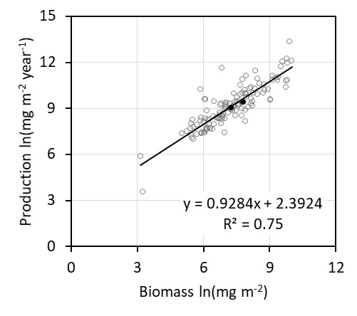
Figure S1. Biomass and annual secondary production of stream macroinvertebrate communities (ash free dry mass, AFDM) from the global synthesis of Patrick and others, 2019 (open grey circles). Glensaugh biomass and daily production estimates (black filled circles) were scaled to annual production (×365 days) and converted to AFDM for comparison, with AFDM=0.9*DM (Eklöf and others, 2017).

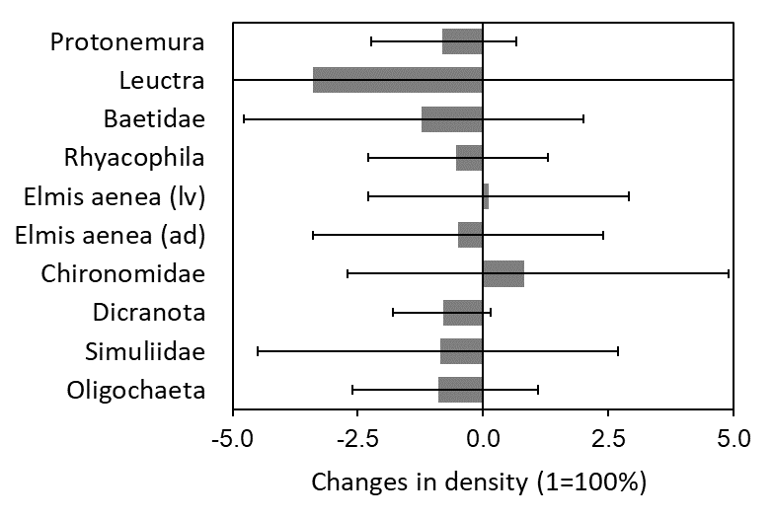
Figure S2. Relative changes in macroinvertebrate densities (individuals m⁻²) due to sucrose addition calculated as the median from 10000 Monte Carlo simulations using the BACI experimental design. Error bars represent the interquartile range. lv=larvae, ad=adult

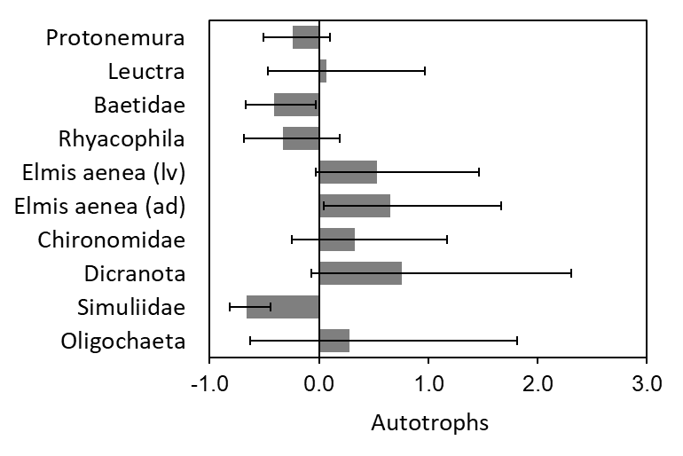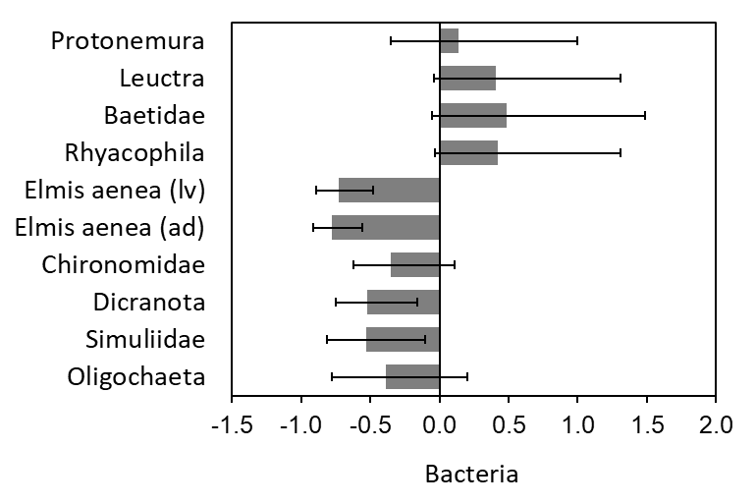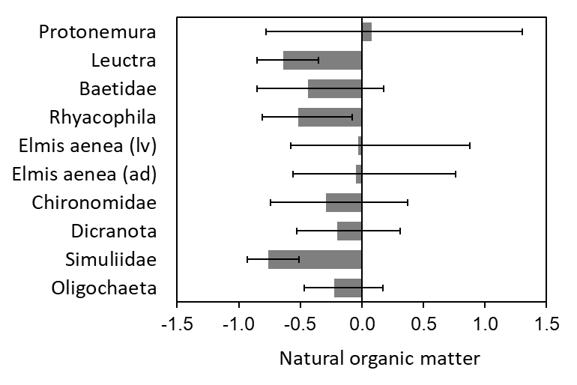
Figure S3. Relative changes (size effects) in primary carbon sources (1=100%): fractions of autotrophs, bacteria and natural terrestrial organic matter carbon sources in macroinvertebrates due to sucrose addition. Size effects were calculated as the median from 10000 Monte Carlo simulations using the reference stream (Birnie after) and treatment stream (Cairn impact). Error bars represent the interquartile range. lv=larvae, ad=adult

Table S1. Carbon isotopic ratio (δ¹³C ±1SD, ‰), fraction of carbon derived from added sucrose F_{S} (±1sd) in macroinvertebrates at equilibrium with the new diet (see method), tissue isotopic turnover rate (λ, day⁻¹), carbon isotopic turnover (τ) 21 days after diet shift, and growth rate (G, day⁻¹) at average stream water temperature of 10.5°C.
Order | Species or taxa | Before  δ¹³C | After  δ¹³C | Control  δ¹³C | Impact  δ¹³C_{(eq)} | Impact  F_{S(eq)} | λ | τ | G
Plecoptera | Protonemura meyeri | ND | -37.29 ±0.73 | ND | -27.31 ±0.70 | 0.39 ±0.04 | 0.15 | 0.98 | 0.022
 | ¹Leuctra | -28.07 ±0.62 | -31.24 ±0.93 | -28.66 ±1.06 | -22.66 ±1.64 | 0.46 ±0.12 | 0.12 | 0.98 | 0.022
 | ²Perlodidae | ND | -30.11 ±0.73 | ND | -24.56 ±0.70 | 0.31 ±0.06 | 0.18 | 0.99 | 0.022
Ephemeroptera | Baetidae (Baetis rhodani) | -31.13 ±1.47 | -37.03 ±0.05 | -29.24 ±0.40 | -23.66 ±0.66 | 0.50 ±0.07 | 0.10 | 0.97 | 0.037
Trichoptera | ³Limnephilidae | -31.46 ±1.23 | -34.71 ±0.69 | -29.57 ±0.15 | -34.54 ±0.69 | -0.08 ±0.08 | 0.11 | 1.01 | 0.023
 | Beraea maurus | ND | -28.99 ±0.73 | ND | -27.14 ±0.70 | 0.11 ±0.06 | 0.13 | 1.00 | 0.023
 | Odontocerum albicorne | -29.91 ±1.58 | -30.42 ±0.90 | -28.32 ±0.38 | -28.46 ±0.95 | 0.02 ±0.12 | 0.13 | 1.00 | 0.023
 | Plectrocnemia conspersa | ND | -30.67 ±0.73 | ND | -25.95 ±0.32 | 0.25 ±0.04 | 0.08 | 0.97 | 0.023
 | ⁴Rhyacophila | -32.93 ±1.26 | -33.42 ±1.01 | -28.56 ±0.53 | -21.49 ±0.93 | 0.44 ±0.12 | 0.07 | 0.93 | 0.023
Coleoptera | Oreodytes sanmarkii (ad) | -31.61 ±0.46 | -32.91 ±0.77 | -29.04 ±0.94 | -29.31 ±0.04 | 0.06 ±0.07 | 0.09 | 1.00 | 0.013
 | Elmis aenea (lv) | -30.83 ±0.28 | -33.98 ±0.33 | -29.25 ±0.23 | -30.88 ±0.28 | 0.07 ±0.03 | 0.12 | 1.00 | 0.013
 | Elmis aenea (ad) | -34.12 ±0.92 | -33.52 ±1.04 | -30.93 ±0.32 | -31.37 ±0.21 | -0.06 ±0.08 | 0.11 | 1.00 | 0.013
 | Elodes sp. (lv) | -29.66 ±0.97 | -30.11 ±0.71 | -28.07 ±0.03 | -22.78 ±0.81 | 0.35 ±0.09 | 0.09 | 0.97 | 0.013
Diptera | ⁵Chironomidae | -28.35 ±1.41 | -34.00 ±2.53 | -29.30 ±0.23 | -27.92 ±1.47 | 0.31 ±0.15 | 0.11 | 1.00 | 0.039
 | Dicranota sp. | -29.32 ±2.17 | -30.88 ±0.13 | -28.81 ±0.46 | -28.03 ±0.31 | 0.13 ±0.12 | 0.08 | 0.99 | 0.034
 | Simuliidae | -28.27 ±0.23 | -34.16 ±0.01 | -28.50 ±0.18 | -16.85 ±0.59 | 0.78 ±0.04 | 0.11 | 0.94 | 0.034
Oligochaeta | Oligochaeta | -28.02 ±0.40 | -27.83 ±0.74 | -26.81 ±0.90 | -26.24 ±0.74 | 0.03 ±0.10 | 0.06 | 0.99 | 0.016
Hydracarina | Hydracarina | ND | -34.07 ±0.73 | ND | -25.76 ±0.70 | 0.38 ±0.05 | 0.14 | 0.98 | 0.021
¹ L. hippopus, L. moselyi, L. fusca, L. inermis, L. nigra
² Isoperla sp., Diura bicaudata
³ Allogamus auricolis, Potamophylax sp.
⁴ R. munda, R. oblitera, R. dorsalis
⁵ mostly Orthocladinae
lv=larvae, ad=adult

Table S2. Partitioning the green web (autotrophs) and brown web (bacteria and soil OM). Proportion (%) of C sources (mean ±SD) in macroinvertebrates in the reference stream (Birnie Burn) before and after sucrose addition. OM=organic matter
Order | Species or taxa | Before  autotrophs | Before  soil OM | After  autotrophs | After  bacteria | After  soil OM
Plecoptera | Protonemura meyeri | ND | ND | 62 ±19 | 25 ±19 | 13 ±11
 | ¹Leuctra | 11 ±12 | 89 ±12 | 22 ±15 | 38 ±23 | 40 ±19
 | ²Perlodidae | ND | ND | 22 ±17 | 33 ±22 | 45 ±20
Ephemeroptera | Baetidae (Baetis rhodani) | 45 ±14 | 56 ±14 | 47 ±23 | 34 ±24 | 20 ±15
Trichoptera | ³Limnephilidae | 46 ±12 | 54 ±12 | 48 ±21 | 34 ±23 | 18 ±13
 | Beraea maurus | ND | ND | 17 ±16 | 27 ±20 | 56 ±22
 | Odontocerum albicorne | 35 ±18 | 65 ±18 | 21 ±16 | 34 ±22 | 46 ±21
 | Plectrocnemia conspersa | ND | ND | 25 ±18 | 36 ±23 | 39 ±19
 | ⁴Rhyacophila | 63 ±15 | 37 ±15 | 34 ±20 | 39 ±24 | 27 ±18
Coleoptera | Oreodytes sanmarkii (ad) | 48 ±11 | 53 ±11 | 31 ±19 | 40 ±24 | 29 ±19
 | Elmis aenea (lv) | 44 ±13 | 57 ±13 | 37 ±20 | 39 ±24 | 24 ±17
 | Elmis aenea (ad) | 74 ±13 | 26 ±13 | 34 ±20 | 40 ±24 | 27 ±18
 | Elodes sp. (lv) | 26 ±11 | 74 ±11 | 19 ±15 | 32 ±22 | 49 ±21
Diptera | ⁵Chironomidae | 10 ±7 | 91 ±7 | 36 ±21 | 39 ±24 | 26 ±18
 | Dicranota sp. | 35 ±20 | 65 ±20 | 21 ±16 | 36 ±22 | 42 ±20
 | Simuliidae | 7 ±5 | 93 ±5 | 39 ±21 | 38 ±23 | 24 ±17
Oligochaeta | Oligochaeta | 6 ±5 | 94 ±5 | 15 ±16 | 23 ±20 | 62 ±26
Hydracarina | Hydracarina | ND | ND | 44 ±21 | 37 ±24 | 19 ±14
¹ L. hippopus, L. moselyi, L. fusca, L. inermis, L. nigra
² Isoperla sp., Diura bicaudata
³ Allogamus auricolis, Potamophylax sp.
⁴ R. munda, R. oblitera, R. dorsalis
⁵ mostly Orthocladinae
lv=larvae, ad=adult

Table S3. Partitioning the green web (autotrophs) and brown web (bacteria and soil OM). Proportion (%) of C sources (mean ±SD) in macroinvertebrates in the treatment stream (Cairn burn) for the control and impact periods of sucrose addition. Note: sucrose was also added as a source for Simuliidae and represented 59 ±14%. OM=organic matter
Order | Species or taxa | Control  autotrophs | Control  soil OM | Impact  bryophytes | Impact  algae | Impact  bacteria | Impact  soil OM
Plecoptera | Protonemura meyeri | ND | ND | 18 ±12 | 29 ±19 | 34 ±13 | 19 ±16
 | ¹Leuctra | 21 ±14 | 79 ±14 | 10 ±8 | 17 ±13 | 58 ±12 | 15 ±12
 | ²Perlodidae | ND | ND | 13 ±9 | 23 ±18 | 39 ±14 | 25 ±17
Ephemeroptera | Baetidae (Baetis rhodani) | 30 ±20 | 70 ±20 | 11 ±8 | 18 ±13 | 57 ±12 | 14 ±12
Trichoptera | ³Limnephilidae | 33 ±20 | 67 ±20 | 62 ±17 | 18 ±15 | 6 ±5 | 15 ±13
 | Beraea maurus | ND | ND | 17 ±12 | 23 ±18 | 19 ±12 | 41 ±21
 | Odontocerum albicorne | 26 ±20 | 74 ±20 | 23 ±14 | 20 ±16 | 14 ±10 | 43 ±21
 | Plectrocnemia conspersa | ND | ND | 15 ±11 | 26 ±19 | 31 ±13 | 29 ±18
 | ⁴Rhyacophila | 28 ±20 | 72 ±20 | 9 ±7 | 16 ±14 | 60 ±13 | 15 ±11
Coleoptera | Oreodytes sanmarkii (ad) | 31 ±21 | 69 ±21 | 26 ±14 | 24 ±17 | 14 ±10 | 36 ±20
 | Elmis aenea (lv) | 30 ±20 | 70 ±20 | 34 ±16 | 26 ±18 | 12 ±9 | 28 ±18
 | Elmis aenea (ad) | 44 ±20 | 56 ±20 | 42 ±16 | 19 ±14 | 10 ±8 | 30 ±19
 | Elodes sp. (lv) | 24 ±19 | 76 ±19 | 10 ±8 | 20 ±17 | 48 ±14 | 21 ±14
Diptera | ⁵Chironomidae | 31 ±20 | 69 ±20 | 20 ±13 | 31 ±20 | 28 ±13 | 22 ±16
 | Dicranota sp. | 22 ±15 | 78 ±15 | 21 ±13 | 25 ±19 | 19 ±11 | 35 ±19
 | Simuliidae | 27 ±20 | 74 ±20 | 6 ±4 | 8 ±6 | 20 ±16 | 7 ±6
Oligochaeta | Oligochaeta | 24 ±21 | 76 ±21 | 15 ±11 | 18 ±15 | 19 ±12 | 49 ±21
Hydracarina | Hydracarina | ND | ND | 15 ±11 | 25 ±18 | 39 ±13 | 21 ±16
¹ L. hippopus, L. moselyi, L. fusca, L. inermis, L. nigra
² Isoperla sp., Diura bicaudata
³ Allogamus auricolis, Potamophylax sp.
⁴ R. munda, R. oblitera, R. dorsalis
⁵ mostly Orthocladinae
lv=larvae, ad=adult

Table S4. Tracing the origin of carbon. Proportion (%) of autochthonous and allochthonous sources (mean ±SD) in macroinvertebrates in the reference and treatment streams following sucrose addition. Note the fraction of sucrose was more accurate when determined directly (see Fs in Table S1). OM=organic matter
 |  | Reference stream (after) |  | Treatment stream (impact)
Order | Species or taxa | Autoch-thonous | Alloch-thonous | Autoch-thonous | Alloch-thonous | Sucrose
Plecoptera | Protonemura meyeri | 62 ±22 | 38 ±16 | 48 ±23 | 27 ±17 | 25 ±17
 | ¹Leuctra | 36 ±19 | 64 ±23 | 35 ±17 | 26 ±13 | 38 ±16
 | ²Perlodidae | 34 ±21 | 66 ±24 | 39 ±21 | 34 ±17 | 27 ±17
Ephemeroptera | Baetidae (Baetis rhodani) | 54 ±27 | 46 ±21 | 37 ±17 | 25 ±13 | 37 ±17
Trichoptera | ³Limnephilidae | 56 ±25 | 44 ±19 | 77 ±23 | 17 ±13 | 6 ±15
 | Beraea maurus | 27 ±19 | 73 ±25 | 40 ±22 | 45 ±21 | 15 ±16
 | Odontocerum albicorne | 33 ±20 | 67 ±25 | 42 ±21 | 46 ±21 | 11 ±16
 | Plectrocnemia conspersa | 38 ±22 | 62 ±24 | 42 ±23 | 35 ±19 | 22 ±17
 | ⁴Rhyacophila | 47 ±24 | 53 ±23 | 33 ±17 | 27 ±13 | 39 ±17
Coleoptera | Oreodytes sanmarkii (ad) | 45 ±24 | 55 ±24 | 49 ±23 | 40 ±20 | 11 ±16
 | Elmis aenea (lv) | 49 ±24 | 51 ±22 | 58 ±25 | 32 ±18 | 11 ±15
 | Elmis aenea (ad) | 47 ±24 | 53 ±23 | 59 ±22 | 33 ±19 | 9 ±15
 | Elodes sp. (lv) | 31 ±20 | 69 ±25 | 36 ±20 | 31 ±15 | 33 ±17
Diptera | ⁵Chironomidae | 48 ±25 | 52 ±23 | 50 ±24 | 28 ±17 | 21 ±17
 | Dicranota sp. | 35 ±20 | 65 ±23 | 45 ±23 | 40 ±20 | 15 ±16
 | Simuliidae | 50 ±25 | 50 ±22 | 16 ±9 | 11 ±7 | 73 ±17
Oligochaeta | Oligochaeta | 24 ±20 | 76 ±28 | 33 ±19 | 53 ±21 | 14 ±16
Hydracarina | Hydracarina | 54 ±25 | 46 ±20 | 43 ±22 | 29 ±16 | 28 ±17

