High aquatic macrophyte diversity in Norwegian lakes north of the arctic circle
Marit Mjelde*, Jan-Erik Thrane & Benoît O.L. Demars
Norwegian Institute for Water Research (NIVA), Økernveien 94, 0579 Oslo, Norway
*Corresponding author: marit.mjelde@niva.no

Supplementary material

Supplementary Tables

Table S1. Aquatic macrophytes in Norway (see Mjelde et al. 2022). Species marked with * are included in the analyses in this article.
Table S2. Correlations between pairs of explanatory variables after log transformation.
Table S3. Area and expected richness for standardised sampling efforts.
Table S4. GAMs for species richness.
Table S5. GAMs for beta-diversity (Sorensen).
Table S6. Generalised additive model (GAM) beta-diversity predicted by differences in lake area, Ca, TP, average summer temperature and latitude.
Table S7. Generalised additive model (GAM) beta-diversity predicted by differences in lake area, Ca, TP, average summer temperature and distance between lakes.

Supplementary Figures
Figure S1. GAM diagnostic plots for species richness.
Figure S2. GAM diagnostic plots for beta-diversity with beta distribution (logit link).
Figure S3. GAM diagnostic plots for beta-diversity with Gaussian distribution (identity link).
Figure S4. Species-area relationships for bioclimatic zones, latitudinal bands and geographical regions.
Figure S5. Species turnover (β_{sim}) predicted by pairwise differences in lake area, Ca, TP, average summer temperature and latitude.
Figure S6. Nestedness (β_{sne}): net species gain or loss predicted by pairwise differences in lake area Ca, TP, average summer temperature and latitude.
Figure S7. Sørensen index (β_{sor}): beta-diversity predicted by distance between lakes (km) and assuming average pairwise differences in lake area, Ca, TP, average summer temperature.
Figure S8. GDM results for compositional dissimilarity (Sorensen beta-diversity).
Table S1. Aquatic macrophytes in Norway (see Mjelde et al. 2022). Species marked with * are included in the analyses in this article.
 | ISOETIDS
* | Baldellia repens (Lam.) Ooststr. Ex Lawalrèe
 | Calamistrum globuliferum (L.) Kuntze
* | Crassula aquatica (L.) Schönl.
 | Crassula helmsii (T. Kirk) Cockayne
* | Elatine hexandra (Lapierre) DC.
* | Elatine hydropiper L.
* | Elatine orthosperma Düben
* | Elatine triandra Schkuhr
* | Eleocharis acicularis (L.) Roem. & Schult.
 | Eleocharis parvula (Roem. & Schult.) Link ex Bluff, Nees & Schauer
* | Isoëtes echinospora Durieu
* | Isoëtes lacustris L.
* | Limosella aquatica L.
* | Littorella uniflora (L.) Asch.
* | Lobelia dortmanna L.
* | Lythrum portula (L.) D.A.Webb
 | Persicaria foliosa (H. Lindb.) Kitag.
* | Ranunculus reptans L.
* | Subularia aquatica L.
 | Ranunculus x levensis Druce ex Gornall (R. flammula x R. reptans)
* | ELODEIDS
 | Callitriche brutia Petagna
* | Callitriche cophocarpa Sendtn. ex Hegelm.
* | Callitriche hamulata Kütz. ex W.D.J.Koch
* | Callitriche hermaphroditica L.
* | Callitriche palustris L.
 | Callitriche platycarpa Kütz.
* | Callitriche stagnalis Scop.
 | Callitriche x vigens K.Martinson (C. cophocarpa x C. platycarpa)
* | Ceratophyllum demersum L.
 | Elatine alsinastrum L.
* | Elodea canadensis Michx.
* | Elodea nuttallii (Planch.) H. St. John
 | Groenlandia densa (L.) Fourr.
 | Hippuris lanceolata Retz.
 | Hippuris tetraphylla L. f.
* | Hippuris vulgaris L.
* | Juncus bulbosus L.
* | Myriophyllum alterniflorum DC.
* | Myriophyllum sibiricum Kom.
* | Myriophyllum spicatum L.
* | Myriophyllum verticillatum L.
* | Najas flexilis (Willd.) Rostk. & W.L.E.Schmidt
 | Najas marina L.
* | Potamogeton alpinus Balb.
* | Potamogeton berchtoldii Fieber
* | Potamogeton compressus L.
* | Potamogeton crispus L.
* | Potamogeton friesii Rupr.
* | Potamogeton gramineus L.
* | Potamogeton lucens L.
* | Potamogeton obtusifolius Mert. & W.D.J.Koch
* | Potamogeton perfoliatus L.
* | Potamogeton praelongus Wulfen
* | Potamogeton pusillus L.
* | Potamogeton rutilus Wolfg.
* | Potamogeton trichoides Cham. & Schltdl.
* | Potamogeton x cognatus Asch. & Graebn. (P.perfoliatus x P. praelongus)
 | Potamogeton x cooperi (Fryer)Fryer (P. crispus x P. perfoliatus)
 | Potamogeton x dualis Hagstr. (P. berchtoldii x P. pusillus)
* | Potamogeton x nericius Hagstr. (P. alpinus x P. gramineus)
* | Potamogeton x nitens Weber (P. gramineus x P. perfoliatus)
* | Potamogeton x prussicus Hagstr. (P. alpinus x P. perfoliatus)
 | Potamogeton x saxonicus Hagstr. (P. berchtoldii x P. obtusifolius)
* | Potamogeton x semifructus A. Benn. ex Asch. & Graebn. (P. friesii x P. obtusifolius)
* | Potamogeton x sparganifolius Læst. ex Fr. (P. gramineus x P. natans)
 | Potamogeton x torssandri (Tiselius)G.Fisch. (P. gramineus x P. lucens x P. perfoliatus)
* | Potamogeton x zizii W.D.J.Koch. ex Roth (P. gramineus x P. lucens)
* | Ranunculus aquatilis L.
 | Ranunculus aquatilis x R. peltatus
 | Ranunculus circinatus Sibth.
* | Ranunculus confervoides (Fr.) Fr.
 | Ranunculus confervoides x R. peltatus
* | Ranunculus peltatus Schrank
 | Ranunculus peltatus x R. trichophyllus
* | Ranunculus trichophyllus Chaix
 | Ruppia cirrhosa (Petagna) Grande
 | Ruppia maritima L.
* | Stuckenia filiformis (Pers.) Börner
* | Stuckenia pectinata (L.) Börner
* | Stuckenia vaginata (Turcz.) Holub
 | Stuckenia x fennica (Hagstr.) Holub (S. filiformis x S. vaginata)
* | Stuckenia x suecica (K.Richt.) Holub (S. filiformis x S. pectinata)
* | Utricularia australis R.Br.
* | Utricularia intermedia Hayne
* | Utricularia minor L.
* | Utricularia ochroleuca R.W.Hartm.
 | Utricularia stygia G.Thor
* | Utricularia vulgaris L.
 | Zannichellia major Boenn. ex Rchb.
* | Zannichellia palustris L.
 | Zannichellia palustris var. pedicullata (Wahlenb. & Rosén)
 | Zostera angustifolia (Hornem.) Rchb.
 | Zostera marina L.
 | Zostera noltei Hornem.
 | NYMPHAEIDS
 | Eleogiton fluitans (L.) Link
* | Luronium natans (L.) Raf.
* | Nuphar lutea (L.) Sm.
* | Nuphar pumila (Timm) DC.
* | Nuphar x spenneriana Gaudin (N. lutea x N. pumila)
* | Nymphaea alba L. coll.
 | Nymphoides peltata (S.S.Gmel) Kuntze
* | Persicaria amphibia (L.) Delarbre
* | Potamogeton natans L.
* | Potamogeton polygonifolius Pourret
* | Sagittaria sagittifolia L.
* | Sagittaria x lunata (C.D.Preston & Uotila) (S. sagittifolia x S. natans)
* | Sparganium angustifolium Michx.
* | Sparganium emersum Rehmann
 | Sparganium glomeratum (Laest. Ex Beurl.) Beurl.
* | Sparganium gramineum Georgi
* | Sparganium hyperboreum Læst. ex Beurl.
* | Sparganium natans L.
 | Sparganium x longifolium Turcz. ex Ledeb. (S. emersum x S. gramineum)
 | Sparganium x oligocarpon Ångstr. (S. emersum x S. natans)
* | Sparganium x speirocephalum Neum. (S. angustifolium x S. gramineum)
* | Sparganium x splendis Meinsh (S. angustifolium x S. emersum)
 | LEMNIDS
 | Azolla filiculoides Lam.
 | Hydrocharis morsus-ranae L.
 | Lemna gibba L.
 | Lemna japonica Landolt
* | Lemna minor L.
 | Lemna minuta Kunth
* | Lemna trisulca L.
 | Lemna turionifera Landolt
 | Pistia stratiotes L.
* | Ricciocarpos natans (L.) Corda
* | Spirodela polyrhiza (L.) Schleid.
 | Stratiotes aloides L.
 | CHAROPHYTES
* | Chara aculeolata Kützing, 1832
* | Chara aspera Willdenow
 | Chara baltica Bruzelius
* | Chara braunii C.C. Gmelin
 | Chara canescens Desvaux & Loiseleur
* | Chara contraria A. Braun ex Kützing
 | Chara curta Nolte ex Kützing
* | Chara globularis Thuiller
* | Chara hispida Linnaeus
* | Chara papillosa Kützing, 1834
* | Chara strigosa A. Braun
* | Chara subspinosa Ruprecht, 1846
* | Chara tomentosa Linnaeus
* | Chara virgata Kützing
 | Chara vulgaris Linnaeus
 | Lamprothamnium papulosum (Wallroth) J.Groves
* | Nitella confervacea (Brébisson) A. Braun ex Leonhardi
* | Nitella flexilis (Linnaeus) C. Agardh
 | Nitella gracilis (Smith) Agardh
* | Nitella mucronata (A. Braun) Miquel
* | Nitella opaca (C. Agardh ex Bruzelius) C. Agardh
* | Nitella translucens (Persoon) C. Agardh
 | Nitella wahlbergiana Wallman
* | Tolypella canadensis Sawa
 | Tolypella nidifica (O. F. Müller) Leonhardi
 | Tolypella normaniana Nordstedt (Nordstedt)

Table S2. Correlations between pairs of explanatory variables after log transformation

Pearson correlations:
lat long elev area Ca TN TP T.av
long 0.8182
elev -0.2052 -0.0386
area -0.0546 -0.0526 -0.0377
Ca 0.1662 0.3358 -0.1009 -0.3723
TN -0.5284 -0.2995 -0.1411 -0.1651 0.4034
TP -0.2898 -0.1003 -0.2090 -0.2952 0.4210 0.6792
T.av -0.6818 -0.3532 -0.1423 -0.0329 0.2024 0.6143 0.4425
colour -0.2789 -0.2554 -0.2966 -0.0244 -0.1202 0.4137 0.5059 0.4081

Number of observations:
lat long elev area Ca TN TP T.av
long 720
elev 716 716
area 713 713 709
Ca 695 695 692 691
TN 505 505 501 505 504
TP 643 643 639 640 640 493
T.av 720 720 716 713 695 505 643
colour 371 371 368 371 370 324 354 371

Pairwise two-sided adjusted p-values (Holm's method)
lat long elev area Ca TN TP T.av
long <.0001
elev <.0001 1.0000
area 0.8725 0.8725 1.0000
Ca 0.0001 <.0001 0.0709 <.0001
TN <.0001 <.0001 0.0155 0.0021 <.0001
TP <.0001 0.0873 <.0001 <.0001 <.0001 <.0001
T.av <.0001 <.0001 0.0016 1.0000 <.0001 <.0001 <.0001
colour <.0001 <.0001 <.0001 1.0000 0.1455 <.0001 <.0001 <.0001

Table S3. Area (km²), observed richness, expected richness and its standard deviation (from species accumulation curves, Fig. 2) for standardised sampling efforts: 37 sites for biogeographical zones, 58 sites for geographical regions and 76 sites for latitudinal bands.
 | Area (km²) | Observed  richness | Expected  richness | ±sd
Biogeographical zones
Boreo-nemoral | 25000 | 82 | 59 | 4.7
South-boreal | 40000 | 85 | 62 | 5.2
Mid-boreal | 65000 | 71 | 55 | 2.7
North-boreal | 90000 | 54 | 45 | 2.8
*Alpine | 100000 | 25 | 25 | 0.6
Geographical regions
Southeast | 79277 | 83 | 69 | 4.0
South | 31732 | 45 | 45 | 0.8
West | 43461 | 58 | 50 | 2.7
Mid | 56381 | 61 | 59 | 1.1
North | 64333 | 62 | 55 | 2.9
Northeast | 48618 | 45 | 44 | 0.6
Latitudinal bands
<60°N | 55900 | 86 | 70 | 4.5
[60-63[ °N | 120199 | 79 | 68 | 3.5
[63-66[ °N | 45515 | 67 | 65 | 1.6
[66-69[ °N | 39411 | 54 | 53 | 0.8
≥69 °N | 63109 | 52 | 52 | 0.6
* since we only sampled low alpine and included sub-arctic area, alpine zone was excluded of the species-area relationship (SAR)
Table S4. GAMs for species richness.

GAM model predictors | df | AIC
area+Ca+TP+T.av+(latitude:longitude) | 47 | 3464
area+Ca+TP+T.av | 25 | 3545
area+Ca+TP+(latitude:longitude) | 42 | 3580
area+TP+T.av+(latitude:longitude) | 39 | 3476
area+T.av+(latitude:longitude) | 33 | 3554
area+(latitude:longitude) | 29 | 3715
area | 5 | 3868

Table S5. GAMs for beta-diversity (Sorensen)

GAM model predictors | df | AIC
area+Ca+TP+T.av+latitude | 46 | -167918
Ca+TP+T.av+latitude | 37 | -167441
Ca+TP+latitude | 29 | -165667
Ca+latitude | 20 | -154716
Ca | 11 | -133830

Table S6. Generalised additive model (GAM) where Sørensen index (β_{sor}), species turnover (β_{sim}) and species net loss or gain (nestedness, β_{sne}) were predicted as a function of differences in lake area, calcium, total phosphorus, average summer temperature and latitude between pairs of lakes. Estimated degrees of freedom (edf) are related to the complexity of trend lines.

beta.sor ~ s(log1p(d.area)) + s(log1p(d.Ca)) + s(log1p(d.TP)) + s(d.T.av) + s(d.lat)
Gaussian distribution with identity function; REML
 | estimate | se | P
intercept | 0.78 | 4 × 10⁻⁴ | <2 × 10⁻¹⁶
 | edf | F | P
log (d.area+1) | 8.8 | 54 | <2 × 10⁻¹⁶
log (d.Ca+1) | 8.6 | 3667 | <2 × 10⁻¹⁶
log (d.TP+1) | 8.5 | 1126 | <2 × 10⁻¹⁶
d.T.av | 7.9 | 213 | <2 × 10⁻¹⁶
d.Lat | 8.9 | 1714 | <2 × 10⁻¹⁶
R² (adj) = 0.29, deviance 29%, n=193131

beta.sim ~ s(log1p(d.area)) + s(log1p(d.Ca)) + s(log1p(d.TP)) + s(d.T.av) + s(d.lat)
Gaussian distribution with identity function; REML
 | estimate | se | P
intercept | 0.66 | 5 × 10⁻⁴ | <2 × 10⁻¹⁶
 | edf | F | P
log (d.area+1) | 8.9 | 340 | <2 × 10⁻¹⁶
log (d.Ca+1) | 8.5 | 2905 | <2 × 10⁻¹⁶
log (d.TP+1) | 8.5 | 789 | <2 × 10⁻¹⁶
d.T.av | 7.5 | 113 | <2 × 10⁻¹⁶
d.Lat | 8.8 | 1378 | <2 × 10⁻¹⁶
R² (adj) = 0.25, deviance 25%, n=193131

beta.sne ~ s(log1p(d.area)) + s(log1p(d.Ca)) + s(log1p(d.TP)) + s(d.T.av) + s(d.lat)
Gaussian distribution with identity function; REML
 | estimate | se | P
intercept | 0.12 | 4 × 10⁻⁴ | <2 × 10⁻¹⁶
 | edf | F | P
log (d.area+1) | 9.0 | 638 | <2 × 10⁻¹⁶
log (d.Ca+1) | 8.6 | 586 | <2 × 10⁻¹⁶
log (d.TP+1) | 7.8 | 109 | <2 × 10⁻¹⁶
d.T.av | 5.7 | 12 | <2 × 10⁻¹⁶
d.Lat | 8.4 | 317 | <2 × 10⁻¹⁶
R² (adj) = 0.09, deviance 9%, n=193131

Table S7. Generalised additive model (GAM) where Sørensen index (β_{sor}), species turnover (β_{sim}) and species net loss or gain (nestedness, β_{sne}) were predicted as a function of differences in lake area, calcium, total phosphorus, average summer temperature and distance (km) between pairs of lakes. Estimated degrees of freedom (edf) are related to the complexity of trend lines.

beta.sor ~ s(log1p(d.area)) + s(log1p(d.Ca)) + s(log1p(d.TP)) + s(d.T.av) + s(distkm)
Gaussian distribution with identity function; REML
 | estimate | se | P
intercept | 0.78 | 4 × 10⁻⁴ | <2 × 10⁻¹⁶
 | edf | F | P
log (d.area+1) | 8.8 | 47 | <2 × 10⁻¹⁶
log (d.Ca+1) | 8.6 | 3703 | <2 × 10⁻¹⁶
log (d.TP+1) | 8.5 | 1197 | <2 × 10⁻¹⁶
d.T.av | 7.9 | 164 | <2 × 10⁻¹⁶
distkm | 8.9 | 1875 | <2 × 10⁻¹⁶
R² (adj) = 0.295, deviance 29.5%, n=193131

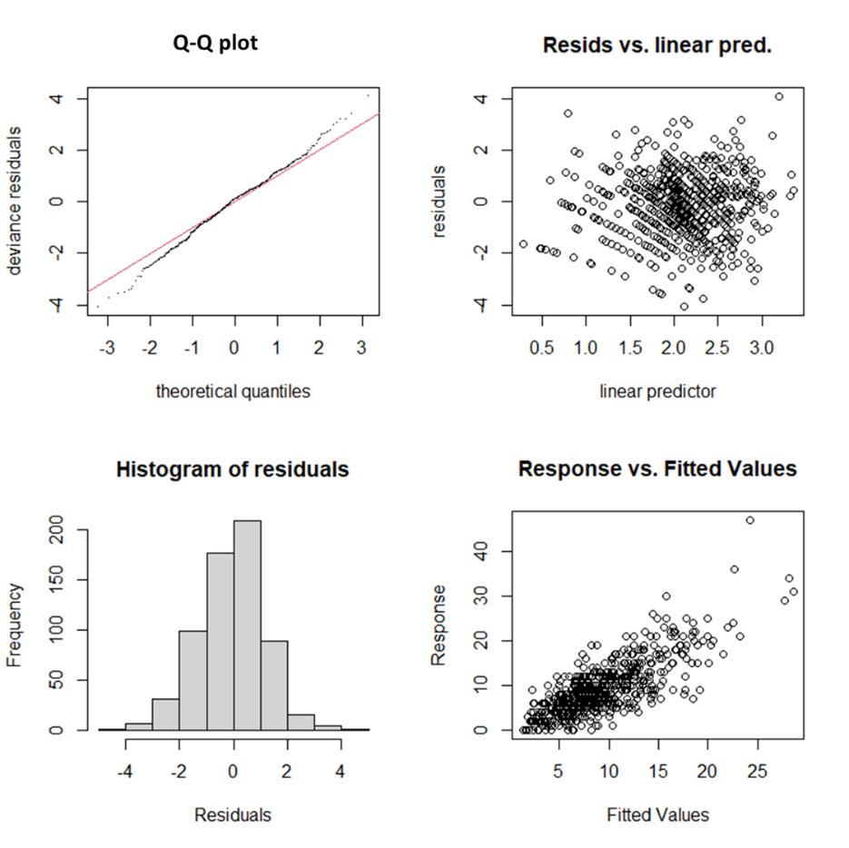
Fig. S1. GAM diagnostic plots for species richness with Poisson distribution (log link)

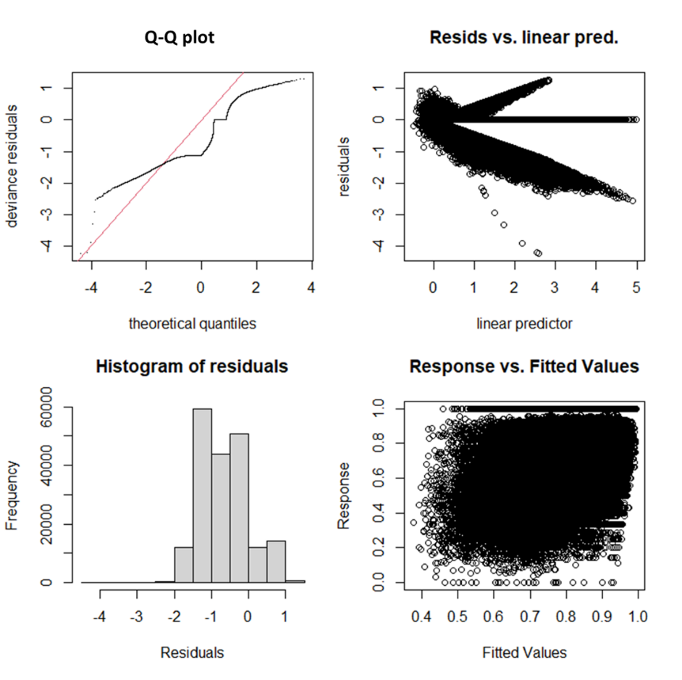
Fig. S2. GAM diagnostic plots for beta-diversity (Sorensen) with beta distribution (logit link)

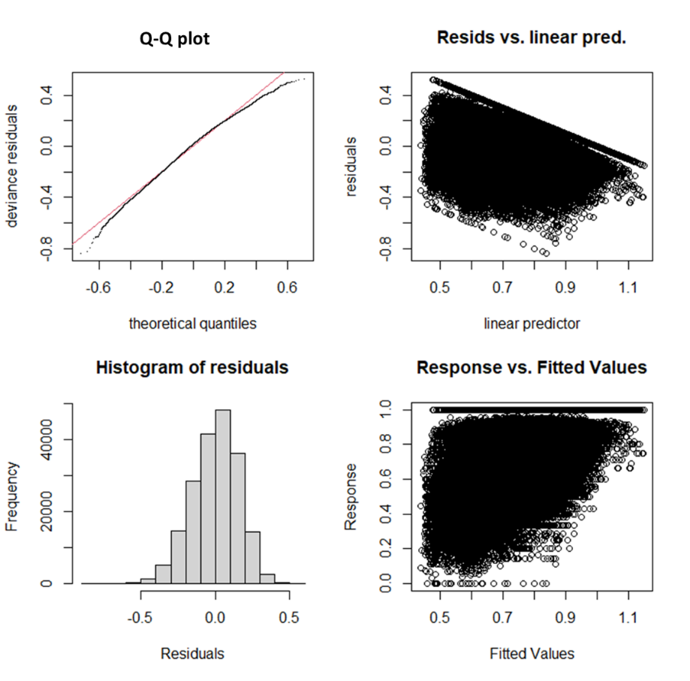
Fig. S3. GAM diagnostic plots with Gaussian distribution (identity link) for beta-diversity (Sorensen)

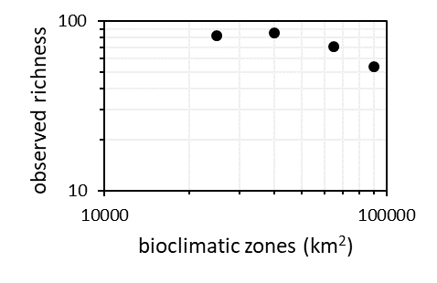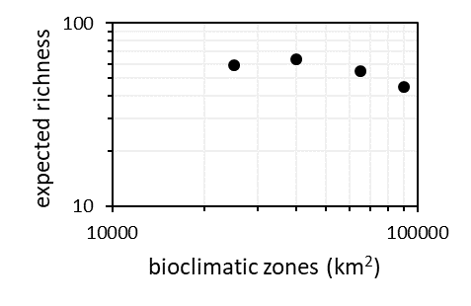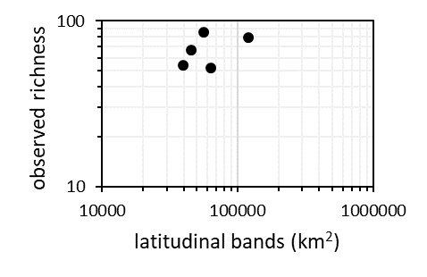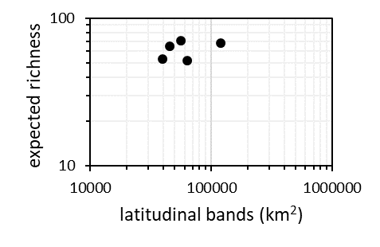
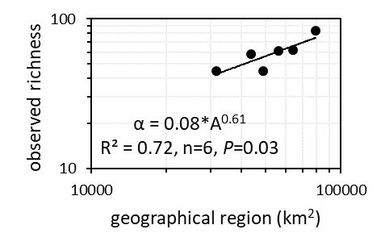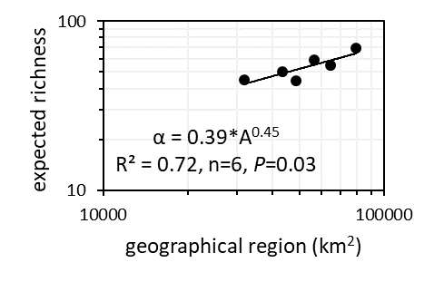
Fig. S4. Species-area relationships. Observed or uncorrected (left) and expected (right) species richness as a function of area for bioclimatic zones (top), latitudinal bands (middle) and geographical regions (bottom). Data from Table S3.

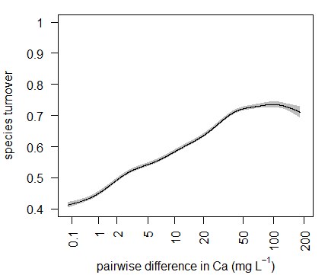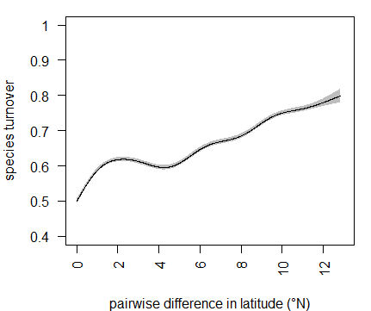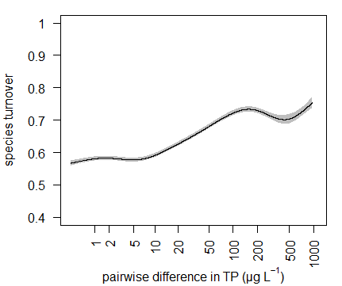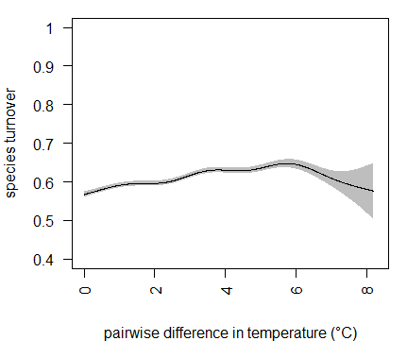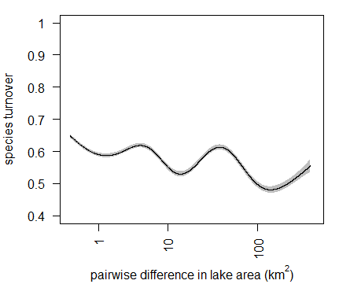
Fig. S5. Species turnover (β_{sim}) predicted by pairwise differences in Ca, TP, latitude, average summer temperature and lake area. Same legend as Fig. 5. See Table S4.

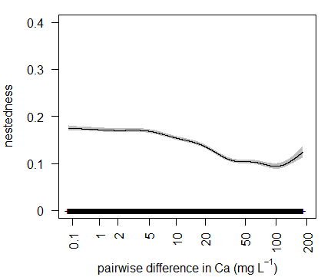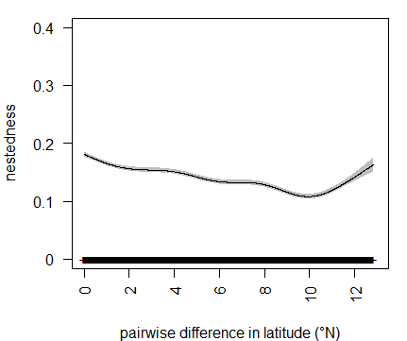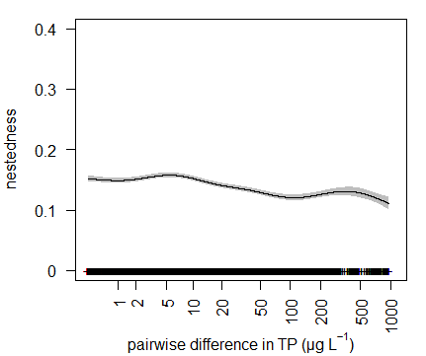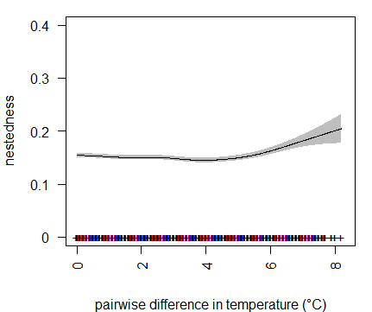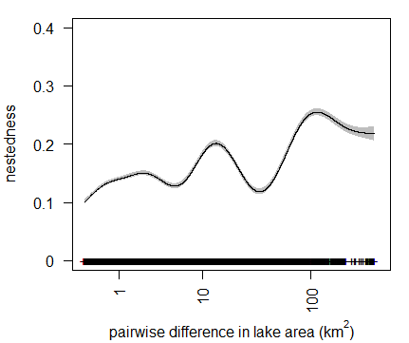
Fig. S6. Nestedness (β_{sne}): net species gain or loss predicted by pairwise differences in Ca, TP, latitude, average summer temperature and lake area. Same legend as Fig. 5. The rug represents the distribution of datapoints along the x axis. See Table S4.

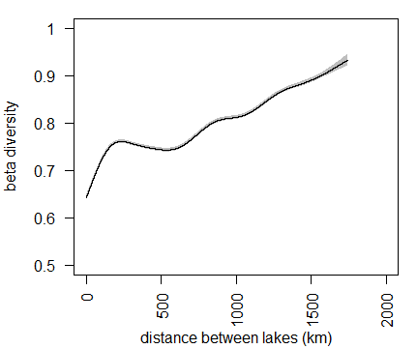
Fig. S7. Sørensen index (β_{sor}): beta-diversity predicted by distance between lakes (km) assuming average pairwise differences in Ca, TP, average summer temperature and lake area. Note the similarity with latitude in Fig. 5. See Table S5.

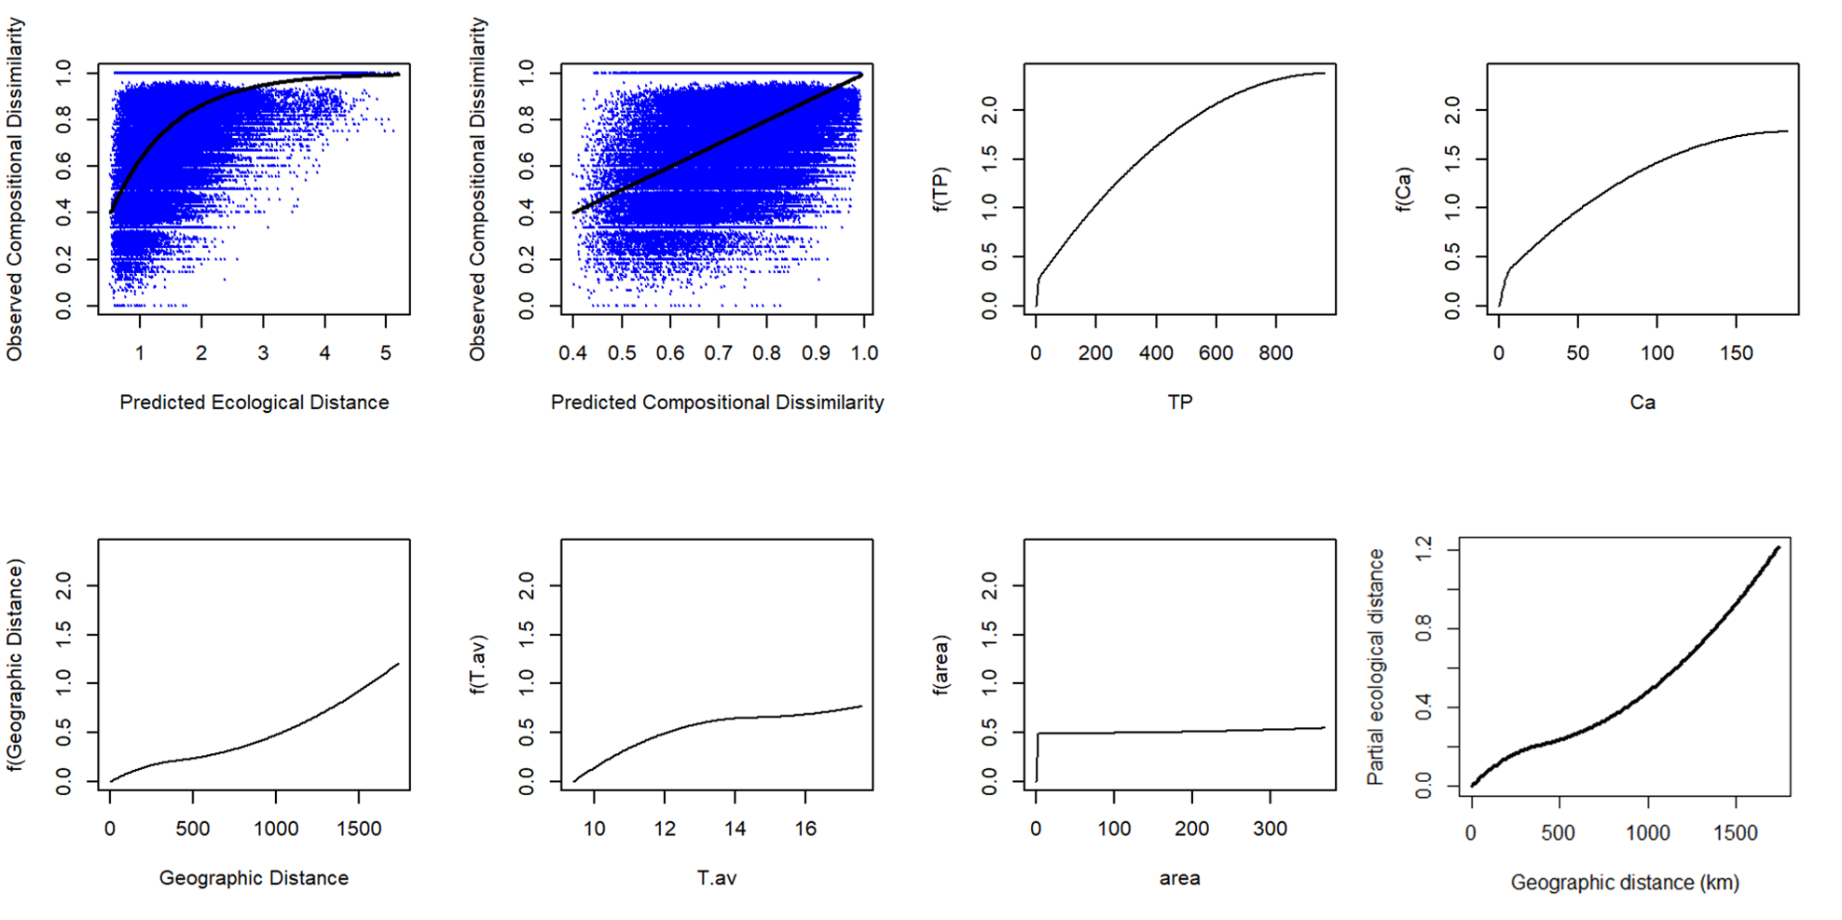
Fig. S8. Generalized dissimilarity modelling (GDM) results for compositional dissimilarity (Sorensen beta-diversity). The results were similar to GAM with explained deviance of 27% (29% for GAM). Both TP (total phosphorus) and Ca were strong predictors in GDM and GAM. TP seemed to be a stronger factor than Ca in GDM (unlike in GAM) but the analyses were based on untransformed differences for GDM and log-transformed differences for Ca, TP and area in GAM.

